Transforming the Lukewarm Rosary
September 24, 2026
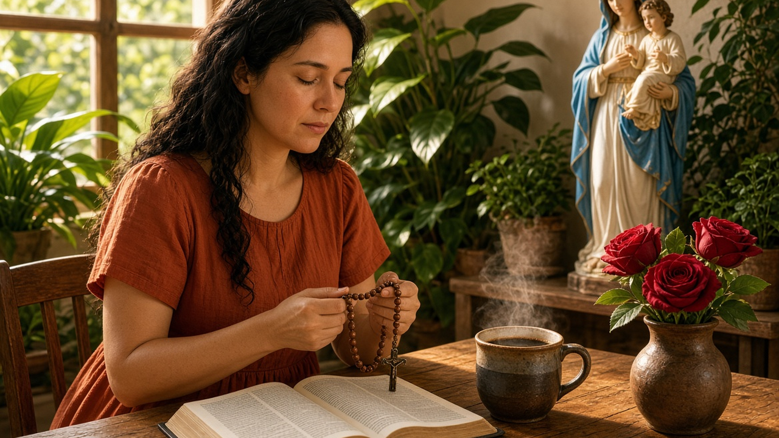
Now, I want to tell you one tactic I pulled off today, and I believe this is going to work every time. Usually when I go to pray, this malaise or sleepiness comes over me. Well, I made a very, very strong cup of coffee and drank it, and I felt that was the prompting of the Holy Spirit. And when I did that, I snapped up.
I paid attention, and I plowed through the opposition, and I was able to connect with my real feelings. Praying the Rosary, I was really centering on Our Lady and praying with deep emotion and feelings, and it totally messed up the lukewarm Rosary. Totally messed it up. All of a sudden I was connected to her. I was connected to the Lord. And as I spoke to them, the words came deeply from my heart.
So this is one way that you can change your prayer life. Consider it prime time. Like first thing in the morning is what the Lord wants. Consider it prime time. Have a good shot of strong coffee. Or if you don't have coffee, I take those little trucker caffeine pills. I take one of those to get my morning started, and that will launch you in to be able to connect with your heart — the things that are on your heart that are hurting you.
And every Rosary is an opportunity to link up the things you're dealing with in present time with the mystery of the Rosary, something about the Lord's life. How He suffered in His family, you know, how He suffered the scourging, the stripes and the crucifixion, and stripping in public, all of His clothes off — all the different things He suffered. You can correlate those, those are the Sorrowful Mysteries, to events in your life that produced similar results.
And that Rosary becomes a real, deep, intense conversation with the Blessed Mother, because we're dealing with the things that are real in our life, that are now urgent, that we need God to help us with. And the strong coffee helps. It helps us to focus right there where the point of pain is. Or if you're praying for other people, the same thing. That intensity makes all the difference in the world.
And in the Rosary, the five mysteries of the Rosary — four mysteries of the Rosary — there's ample place to put your own mystery. In other words, just take an incident out of the Lord's life and give that life in your own circumstance and parallel the two together. And when you pray it, pray it with passion. And that's the way I'm going to change back to doing the Rosary when it was really effective for me, because that's exactly how I used to do it, and I haven't been doing that.
So, go to the Lord in the morning. That time is sacrosanct. Don't allow anyone or anything to pull you off track, because that's what they've been doing on the refuge. Every morning they set up brush fires. You know, this one has that problem, that one has this problem, on and on.
And we can't allow that to happen anymore. We have to say no. I'm not going to deal with this now. I'll deal with it after prayer, which of course is always the right way to do it. And really connect in prayer.
And you don't have to pray the whole Rosary. Contrary to popular opinion, you don't have to pray the whole thing. Pray the things that you can put passion into. Real passion. Pray those things, and you'll connect with Our Lady and Our Lord much faster than if you try to go on with a rote Rosary.
Make it a deep conversation. I'm not a fly-by McDonald's grab-a-hamburger conversation, but a really deep conversation where you feel connected with passion to God and to Our Lady because you really mean it.
You're taking the time to match up your problems, the world's problems, with the life of Jesus, meditating on His life and praying for them. So that's my secret to having a more intense Rosary. And I did that for years and years and years. And I'm going back to it.
And don't strangle yourself trying to do all the mysteries. Go as far as you can that is real. In real time you're really feeling it. You're really connected. And when you resolve that, that's a good time to stop and go on and do something else.
So the Lord bless you with wisdom on how to handle these cross currents that the enemy has sent to derail our prayers.
Get deep, get intense, get committed, and you will see real results. I promise you.

